Chapter 9, Solution 79.

- Consider the circuit as shown.
20 
30 
j10 
j60 
+
V_{i}
−

+
V_{o}
−

40 
j30 
V₂
Z₂
V₁
Z₁

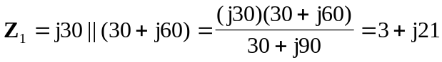

Let 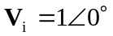.

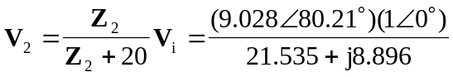
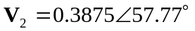

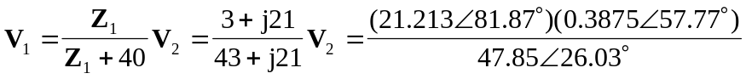
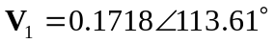

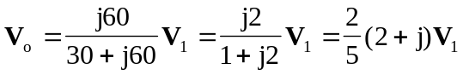
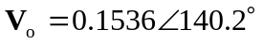

Therefore, the phase shift is 140.2

- The phase shift is leading.

- If 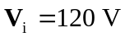, then
V
and the magnitude is 18.43 V.

